**EXPERIMENT 2**

**SOLUTION OF ORDINARY DIFFERENTIAL EQUATIONS**

1. **EULER’S METHOD:**

**CASE 1:**

**CODE:**

clc

clear all

f=@(x,y) -2.2067*10^-12*(y^4-81*10^8);

x0=0;

y0=1200;

xC=480;

h=120; %interval taken

p=(xC-x0)/h;

%euler's formula

for i=1:p

y1=y0+h*f(x0,y0);

x0=x0+h;

y0=y1;

fprintf('The value of %0.4f is %0.4f\n',x0,y0);

end

**OUTPUT:**

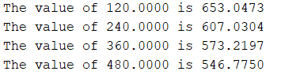

**CASE 2:**

**CODE:**

clc

clear all

f=@(x,y) 2+sqrt(x*y);

x0=0;

y0=1;

xC=2;

h=0.1;

x1=x0+h;

p=(xC-x0)/h;

%eulers_method

for i=1:p

y1=y0+h*f(x0,y0);

x0=x0+h;

y0=y1;

fprintf('The value of %0.4f is %0.4f\n',x0,y0);

end

**OUTPUT:**

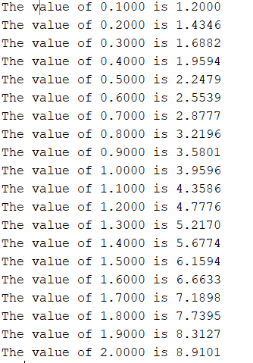

1. **MODIFIED EULER’S METHOD:**

**CASE 1:**

**CODE:**

clc

clear all

f=@(x,y) -2.2067*10^-12*(y^4-81*10^8);

x0=0;

y0=1200;

xC=480;

h=120; %interval taken

p=(xC-x0)/h;

x1=x0+h;

%modified euler's formula

for i=1:p

y1=y0+h*f(x0,y0);

y2=y0+(h*(f(x0,y0)+f(x1,y1))/2);

x0=x0+h;

x1=x1+h;

y0=y2;

fprintf('The value of %0.4f is %0.4f\n',x0,y2);

end

**OUTPUT:**

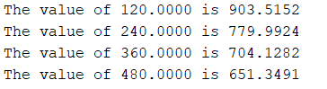

**CASE 2:**

**CODE:**

clc

clear all

f=@(x,y) 2+sqrt(x*y);

x0=0;

y0=1;

xC=2;

h=0.1;

x1=x0+h;

p=(xC-x0)/h;

%modified_eulers

for i=1:p

y1=y0+h*f(x0,y0);

y2=y0+(h*(f(x0,y0)+f(x1,y1))/2);

x0=x0+h;

x1=x1+h;

y0=y2;

fprintf('The value of %0.4f is %0.4f\n',x0,y2);

end

**OUTPUT:**

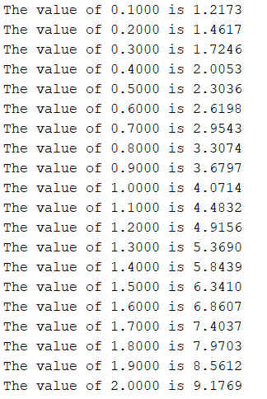

1. **RK 2 METHOD:**

**CASE 1:**

**CODE:**

clc

clear all

f=@(x,y) -2.2067*10^-12*(y^4-81*10^8);

x0=0;

y0=1200;

xC=480;

h=120; %interval taken

x1=x0+h;

p=(xC-x0)/h;

%rk 2 method:

for i=1:p

k1=f(x0,y0);

k2=f(x0+h,y0+(k1*h));

y1=y0+(h*(k1+k2)/2);

x0=x0+h;

y0=y1;

fprintf('The value of %0.4f is %0.4f\n',x0,y1);

end

**OUTPUT:**

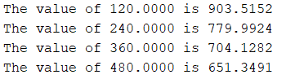

**CASE 2:**

**CODE:**

clc

clear all

f=@(x,y) 2+sqrt(x*y);

x0=0;

y0=1;

xC=2;

h=0.1;

x1=x0+h;

p=(xC-x0)/h;

%rk 2 method:

for i=1:p

k1=f(x0,y0);

k2=f(x0+h,y0+(k1*h));

y1=y0+(h*(k1+k2)/2);

x0=x0+h;

y0=y1;

fprintf('The value of %0.4f is %0.4f\n',x0,y1);

end

**OUTPUT:**

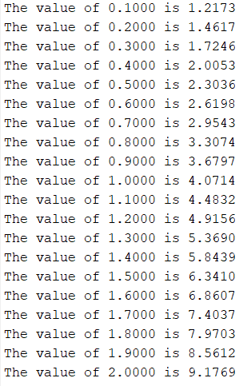

1. **RK 4 METHOD:**

**CASE 1:**

**CODE:**

clc

clear all

f=@(x,y) -2.2067*10^-12*(y^4-81*10^8);

x0=0;

y0=1200;

xC=480;

h=120; %interval taken

x1=x0+h;

p=(xC-x0)/h;

%rk 2 modified method or RK 4 Method:

for i=1:p

k1=f(x0,y0);

k2=f(x0+(h/2),y0+(k1*h/2));

k3=f(x0+(h/2),y0+(k2*h/2));

k4=f(x0+h,y0+k3*h);

y1=y0+(h*(k1+2*(k2+k3)+k4)/6);

x0=x0+h;

y0=y1;

fprintf('The value of %0.4f is %0.4f\n',x0,y1);

end

**OUTPUT:**

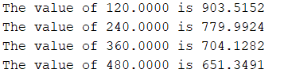

**CASE 2:**

**CODE:**

clc

clear all

f=@(x,y) 2+sqrt(x*y);

x0=0;

y0=1;

xC=2;

h=0.1;

x1=x0+h;

p=(xC-x0)/h;

%rk 2 modified method or RK 4 Method:

for i=1:p

k1=f(x0,y0);

k2=f(x0+(h/2),y0+(k1*h/2));

k3=f(x0+(h/2),y0+(k2*h/2));

k4=f(x0+h,y0+k3*h);

y1=y0+(h*(k1+2*(k2+k3)+k4)/6);

x0=x0+h;

y0=y1;

fprintf('The value of %0.4f is %0.4f\n',x0,y1);

end

**OUTPUT:**

